P10 Clot Capstone

Final Proposal

Josette Vigil
Devin Roser
Courtney West
Hunter Gaines

2022-2023


Project Sponsor: Bioengineering Devices Laboratory
Faculty Advisor: Dr. Tim Becker
Instructor: Dr. Armin Eilaghi

DISCLAIMER
This report was prepared by students as part of a university course requirement. While considerable effort has been put into the project, it is not the work of licensed engineers and has not undergone the extensive verification that is common in the profession. The information, data, conclusions, and content of this report should not be relied on or utilized without thorough, independent testing and verification. University faculty members may have been associated with this project as advisors, sponsors, or course instructors, but as such they are not responsible for the accuracy of results or conclusions.

EXECUTIVE SUMMARY
The clot capstone group is creating a procedure for developing and testing synthetic thrombi or blood clots for the BDL and the client Dr. Becker. These clots need to have their material properties validated against those of real blood clots and other synthetic blood clots that are used as an industry standard. Synthetic blood clots are used when testing medical devices that are used in thrombectomies instead of whole blood clots that need to be obtained by harvesting them from animals. The clot capstone group has developed a protocol for polymer synthesis in creating synthetic blood clots for a soft clot, hard clot and a medium clot. The team has successfully begun creating batches of these synthetic clots with consistent properties and has begun to develop a procedure in order to validate the material properties of the clots when compared to whole blood clots and synthetic blood clots that are used as an industry standard. The properties that are being examined by the group are as follows: The shear and elastic moduli of the synthesized clots in order to determine the stiffness and if the clots are cured properly using a Rheometer located in the BDL lab, the radiopacity of the clots, which is the ability for the clots to appear on a fluoroscope that the group has been given access to through the BDL lab by introducing a contrast agent to the clots, and the benchtop occlusion test which tests to see how well the synthesized clots can simulate real blood clots when they cause a stroke. The group analyzed the risk with the tests that are being run on the clots, The highest points of risk and failure that were determined were chemical failures, curing failures, rheometer testing failures, occlusion failures and storage failures. Failures with the chemical creation could lead to serious health hazards as well as an unsuitable batch of synthetic clots, failure in the curing stage will lead to untestable and non-homogenous clots, a testing failure with the rheometer would lead to non-usable data when comparing the synthesized clots to real clots, occlusion failures would most likely lead to the destruction of the clot being tested, and storage failures would impose the risk of the clots drying out and becoming untestable or over curing and having the wrong material properties. The chemical process in creating the clots has not been altered since the functional decomposition was created. This process involves mixing several chemical reagents and then degassing and then curing the solution in order to make synthetic clots. The final design that was selected for the clots was the 1 ml syringe. The 1 ml syringe did not score the highest on the Pugh chart, but the puck model was deemed to be unusable after material testing began. The puck model was unable to cure properly and the 1ml syringe design was able to be tested on the rheometer after the sample was extracted from the syringe and cut into small pieces as the width of the clot was approximately 4mm which was the width that the puck model would have been. The group needs to finish shear and elastic modulus testing, radio capacity testing and occlusion testing for all three desired clot types. In the next semester, the group will complete all material testing for the clots, finalize the wight percentages needed in order to create all three desired stiffnesses of clots and finish experimenting with different storage designs in order to find an optimal method that allows for the clots to be, cured, tested and prevents them from drying out over extended periods of time.

TABLE OF CONTENTS

DISCLAIMER 1
EXECUTIVE SUMMARY 2
TABLE OF CONTENTS 3
1 BACKGROUND 4
1.1 Introduction 4
1.2 Project Description 2
2 REQUIREMENTS 2
2.1 Customer Requirements (CRs) 2
2.2 Engineering Requirements (ERs) 3
2.3 Functional Decomposition 4
2.3.1 Black Box Model 4
2.3.2 Functional Model/Work-Process Diagram/Hierarchical Task Analysis 4
2.4 House of Quality (HoQ) 5
2.5 Standards, Codes, and Regulations 6
3 Testing Procedures (TPs) 7
3.1 Testing Procedure 1: Shear and Elastic Moduli 7
3.1.1 Testing Procedure 1: Objective 7
3.1.2 Testing Procedure 1: Resources Required 7
3.1.3 Testing Procedure 1: Schedule 8
3.2 Testing Procedure 2: Radiopacity 8
3.2.1 Testing Procedure 2: Objective 8
3.2.2 Testing Procedure 2: Resources Required 8
3.2.3 Testing Procedure 2: Schedule 9
3.3 Testing Procedure 3: Benchtop Occlusion 9
3.3.1 Testing Procedure 3: Objective 9
3.3.2 Testing Procedure 3: Resources Required 9
3.3.3 Testing Procedure 3: Schedule 10
4 Risk Analysis and Mitigation 10
4.1 Critical Failures 10
4.1.1 Potential Critical Failure 1: Chemical Failures 12
4.1.2 Potential Critical Failure 2: Curing Failures 12
4.1.3 Potential Critical Failure 3: Material Testing Failures 13
4.1.4 Potential Critical Failure 4: Benchtop Occlusion Testing Failures 13
4.1.5 Potential Critical Failure 5: Storage Failures 14
4.2 Risks and Trade-offs Analysis 14
4.2.1 Risks and Trade-offs of Size Versus Comparability 14
4.2.2 Risks and Trade-offs of Curing Versus Testability 15
4.2.3 Risks and Trade-offs of Bench Testing Versus Storage 15
5 Design Selection—First Semester 15
5.1 Design Description 15
5.2 Implementation Plan 17
6 CONCLUSIONS 19
7 REFERENCES 20
8 APPENDICES 22
8.1 Appendix A: Complete FMEA 22
8.2 Appendix B: Design Selection Materials 23
8.3 Appendix C: Final CAD and BOM 23

BACKGROUND

Introduction
Nearly 800,000 Americans suffer from ischemic stroke each year. Stroke is the leading cause of serious long- term disability in the United States [1]. 87% of stroke patients experience ischemic stroke, of which 24-46% come from large vessel occlusions (LVO) [2]. Clot retrieval (thrombectomy) must be performed quickly to save brain tissue and maximize recovery. Mechanical thrombectomy, using an aspiration catheter or stent retriever, is becoming the standard of care for eligible patients with LVO stroke. Updated test methods for these devices have the potential to improve patient outcomes and inform treatment options. Characterizing synthetic thrombi and comparing their properties to the whole blood clots currently used for device testing will enhance the quality of data collected. Knowing the mechanical behavior of thrombi allows engineers and clinicians to determine device performance under different patient circumstances, allowing them to troubleshoot devices prior to use.

The goal of this project is to inform the creation and use of synthetic blood clots for in-vitro medical device demonstrations, testing, and training. Currently, animal (whole) blood clots are used for this purpose, specifically to inform the use of thrombectomy devices. Whole animal blood clots are created from blood directly harvested from a subject (typically porcine or ovine). This blood is run through a centrifuge process, and chemical additives are used to create contrast or other desired characteristics. In recent years, synthetic clots have arrived on the market to replace whole blood clots in benchtop device testing and demonstrations. Synthetic thrombi are easier to obtain, faster to produce, and more customizable in their properties. Artificial clots can assume different colors, stiffnesses, homogeneities, and types of contrast, making them a desirable option for thrombectomy device testing. This project is sponsored by Northern Arizona University’s (NAU) Bioengineering Devices Laboratory (BDL). Upon completion of this project, the sponsor will be able to sell synthetic clots to medical technology companies for device testing.

Project Description
Following is the original project description provided by the sponsor in bulleted form:
“Develop a protocol for polymer synthesis in the Bioengineering Devices Lab
- Research existing protocols for hydrogel polymer synthesis, and whole blood clot creation
- Complete NAU BioRaft chemical and X-ray safety training
- Experiment with polymer synthesis using equipment at BDL (create soft, firm, and radiopaque clots)
  - Validate consistency in the material properties by developing and standardizing mechanical testing procedures (i.e., compression, shear, Poisson’s Ratio)
  - Write SOPs for final clot designs and mechanical testing procedures using BDL format
Characterize the material properties of lab-created polymer, commercial polymer, and whole blood clots
- Complete NAU BioRaft Bloodborne Pathogens training, in addition to rheometer use testing
- Perform data analysis on all synthetic clots to determine the degree of similarity to the control (whole blood clots)
- Report all findings in a final written analysis”
Currently, there have not been any revisions to this project description.

REQUIREMENTS
The Clot Capstone team will be creating synthetic thrombi throughout the semester while adhering to a certain set of customer requirements and engineering requirements. The client, Dr. Becker, described the project to the team and the goals associated with the project. This allowed the team to list the client needs and engineering requirements necessary to meet the project goals and have successful manufacturing and material testing of the synthetic clots.

Customer Requirements (CRs)
The team worked with Dr. Becker to create a list of customer requirements for the clot capstone project. These requirements are based on the desired characteristics for the synthetic clots and aid the team in making decisions when manufacturing the clots. After discussion amongst the team and the client, the team decided on seven customer needs for the project. These include manufacturability, ability to test material properties, consistent surface texture, consistency of whole blood clots, uniform size, time to produce, and creation using hydrogels/polymers. Each of these requirements were weighed on a scale of one to four to decide which needs were most important for the success of the project.

Manufacturability was heavily weighted, with a score of four, due to its importance to the project. Manufacturing clots is one of two main objectives the team is looking to achieve throughout the duration of the project, so having a product that can be replicated easily is critical for the team’s success. The second goal of the project is to test the material properties of the clots being created. The ability to test material properties was also given a weight of four in the QFD. Creating a product that can be tested using the rheometer is slightly different from the products that will be used in medical testing. Being able to create a testable puck and a clot that has the same material properties is one challenge the team will be working towards during the two semesters of the project. The last customer requirement receiving a heavy weight and score of four is consistency like whole blood clots. This is the main purpose of the project, and the reason scientists are interested in creating synthetic clots. Being able to replicate the consistency of human blood clots and create a product that acts and feels like a whole clot will allow the team to use these synthetic thrombi in medical testing and training.

Creation of the clots using a hydrogel/polymer was given a score of three in the QFD. Using these types of materials when creating clots is of high importance as hydrogels and polymers will resemble whole clots the closest. The BDL lab has used this type of material to create many of the products used in medical device testing and will be the best approach for the team to create soft, medium, and hard clots. Consistent surface texture was given a score of two in the QFD. This requirement is given a mid-range score for importance because it is not necessary for the clots to have consistent surface texture but is a desired feature both the team and client are looking for in the product. The surface texture will be impacted by the method of curing and the type of mold being used to store the clots in. The team will use means of storage that will create the best surface textures in the form of syringes and silicon molds. Uniform size is a requirement that was given a score of two in the QFD. The use of syringes and silicon molds will also help with the uniformity of the product. The team wants to have clots that are uniform in size, but if they are not exactly uniform this will not be looked at as a failure. The final customer requirement for the project is time to produce. This is weighted the lowest with a score of one. Although it would be best to have a product that takes minimal amounts of time to create, any time needed to create a product that meets all other requirements will be acceptable. This was included as a requirement because some types of synthetic thrombi can take large amounts of time to create, and the team wanted to try to identify the best method for creation with time being accounted for.

Engineering Requirements (ERs)
The team used a selection of engineering requirements to quantify the customer requirements and give measurable parameters for the project. Engineering requirements for synthetic clots include modulus of elasticity, viscosity, chemical stability, shear modulus, tensile strength, surface roughness, and cost. These requirements are related closest to the material properties of the clots, but some are connected closely with safety and economics.
Modulus of elasticity, shear modulus, tensile strength, and viscosity will be tested using the rheometer in the lab. Values for these individual parameters will vary based on the hardness of the clot and will be compared to whole clot data. These engineering requirements will help the team understand the mechanical properties of the specimens being tested and give the team knowledge on how to alter the chemicals in our solution to produce clots that resemble whole blood closest. Chemical stability of the clots is important because the clots need to be able to be stored without degrading and maintain their shape and size when being handled. If the clots are unstable, they can continue to have chemical reactions after the manufacturing process has ended that will negatively impact the properties of the product. The chemicals being used to create the clots are toxic to humans and can be more dangerous if unstable. Another measurable parameter the team will focus on is the surface roughness of the clots. This will be measured visually after the clots have completed their curing process. The roughness of the clot is important to the team because the clots need to be smooth on the outside when used in medical testing equipment. The clots will not be seen as successful if they have bumps or lesions on the surface. The last measurable quantity the team will account for is the cost of the clots. Keeping the cost down for the clots is desirable but not critical to the success of the project. If the clots being manufactured were being marketed and sold, the cost would be much more important, but for the purpose of creating clots that have the best properties possible, cost is not a defining factor. Each of these parameters are important to the success of the project, with some being more important than others, and will be referred to throughout the semester to maintain consistency.

Functional Decomposition
The functional decomposition for this project is demonstrated through both a black box model and a functional model. The black box model describes the primary mechanism in bare-bones format. The functional model is a more detailed examination of the inputs and outputs of the system.

Black Box Model
The black box model (Figure 1) breaks the manufacturing process into its reactants and products. It is a broad strokes overview, used for reverse engineering purposes only, and for the team to determine the unchangeable parts of our process as opposed to the flexible elements.
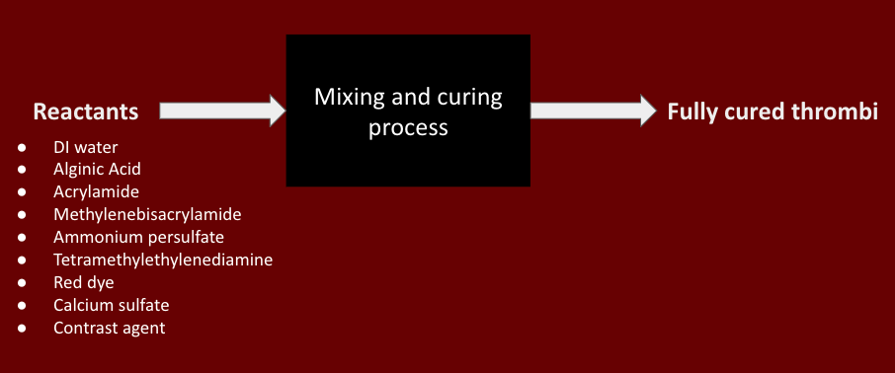
Figure 1: Black Box Model
The reactants are shown as an input arrow, which is solid as it is a material. The mixing and curing process is the primary function of our manufacturing process. The output material is fully cured thrombi, shown on the right side of the figure.

Functional Model/Work-Process Diagram/Hierarchical Task Analysis
The functional model describes the manufacturing process in more detail. Each step of the chemical addition, and mixing processes are denoted by solid lines for materials, and dashed lines for energy inputs. There are no signal inputs for this process. The curing process is the primary subsystem under investigation in our experimentation since the mixing steps are crucial to the chemical reaction mechanisms. Additionally, the molds are under investigation as well as the amounts of each chemical added. Contrast is not shown in this model, as we are still determining the best step for its addition. Currently, we believe the contrast should be added with the DI water.
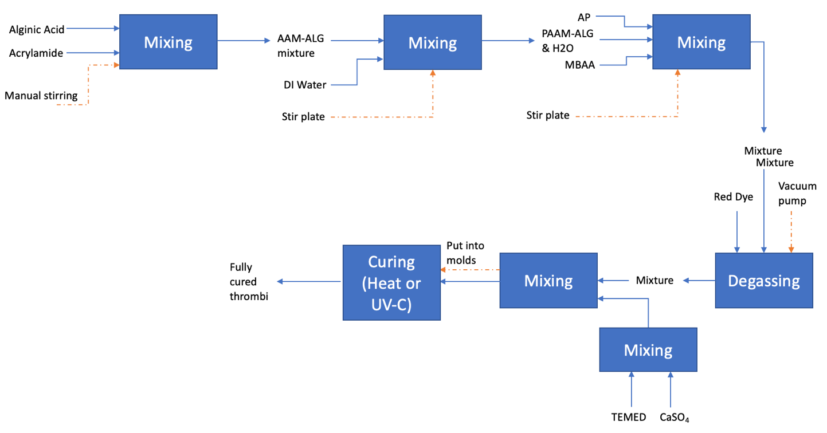
Figure 2: Functional Decomposition

House of Quality (HoQ)
The clot team compiled the customer and engineering requirements in a QFD to determine the customer needs that impacted the project greatest. The team used the previously mentioned weighted scores for the customer needs and related those to the technical requirements to determine which parameters need to be focused on when manufacturing the clots. After completing the analysis in the QFD, shown in Figure 2, the team identified viscosity to be the most impactful parameter. The clots must have an appropriate viscosity to be tested for material properties and to be used in medical device training. Chemical stability was found to be the second most important parameter. Products being chemically unstable cannot be tested properly and will create issues for the team and anyone handling the product. Surface roughness was the third most important. Clots need to be smooth in order to be used for training. If the clots produced cannot be used for medical training, the team has failed and has not manufactured an adequate clot.
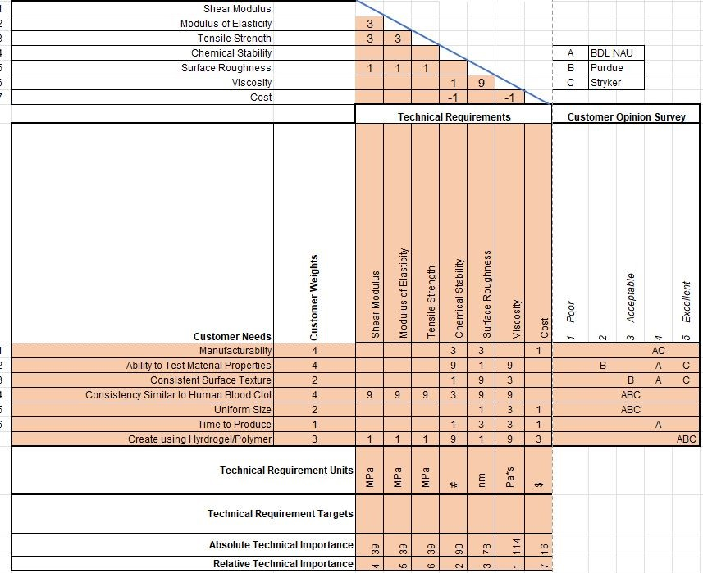
Figure 3: QFD
The analysis within the QFD helped the team have a better understanding of the individual impacts the technical requirements would have on the success of the project. This information helped the team in the design process by pointing them in the direction of better curing methods and storage. The curing process and storage of the clots will have the strongest connection with viscosity and chemical stability. Prior to this analysis, the team was more focused on having a product that had material properties like whole blood as the main goal, but the QFD proved that it would not be possible without a few other requirements being met first. The QFD proved to be a great tool for the team and helped the team focus on how to approach the clot making procedure while keeping important requirements in mind.

Standards, Codes, and Regulations
Since this project is exploring a new method of in vitro testing, there aren’t any engineering standards in place for its use. However, we are accountable for adhering to the ethics of research conduct. It is imperative that all the data collected is honestly and ethically done. Our mistakes and any errors will be documented, as is the lab practice. Any anomalies present in the data will be enumerated in our reporting, and we will troubleshoot our methods for errors as testing progresses, so that everything is above board. Manufacturing methods will also be documented thoroughly to ensure consistency and validity of all results.

Testing Procedures (TPs)
This section will describe the testing procedures used to verify the manufacturing processes for the synthetic thrombi and the material properties of the fully cured polymers. There are 3 testing procedures in total, the radiopacity test, shear and elastic moduli tests, and a benchtop occlusion test. If possible, the samples will be analyzed under a microscope for damage or degradation during testing.

Testing Procedure 1: Shear and Elastic Moduli
The most important testing procedure in this project is the shear and elastic modulus testing. These tests will be used to determine the stiffness and material properties of the fully cured thrombi.

Testing Procedure 1: Objective
The primary objective is to identify the shear and elastic modulus of the sample the team has manufactured. This is achieved by cutting small samples from the polymers being stored in the syringes. The syringes are roughly 4-mm in diameter and the wanted sample height is 4-mm. This small cylinder sample is then placed on the rheometer to be tested. The rheometer plate is heated to 37C to mimic the human body temperature. Once the plate is heated and the sample has settled underneath the rheometer, the rheometer will then be programmed to apply a certain force to the sample. The rheometer will measure the force the sample is pushing back with and the deformation of the sample to provide values for the elastic modulus. When testing for the shear modulus, the same procedure is carried out, but the rheometer will also apply a torsional force to test for the shear modulus of the material. The shear and elastic modulus are important for defining the type of human clot our manufactured clots will resemble. Our client identifies hard, soft, and medium clots each of which have distinct moduli. Once these properties are characterized, our manufactured samples can be categorized and used for testing.

Testing Procedure 1: Resources Required
To test for these properties, one to two people are sufficient for successfully testing the samples. The testing and preparation go more smoothly with two people, but one is enough. The rheometer is the most important tool needed to conduct these tests. The rheometer is paired with the TRIOS software package and will not provide numerical or graphical data without this program. For the samples, the previously manufactured clots will need to be cut using a small scalpel while being measured with a small caliper. Once the samples have been cut to size, they will need to be stored in an airtight and non-light exposed container, with a small amount of humidity to maintain the original properties of the product. Using a 4-mm biopsy punch, a team member will need to get two circular pieces of sandpaper to attach to the bottom and top of the contact areas on the rheometer. The sandpaper will prevent slipping of the sample when applying torsional forces. Tweezers, gloves, goggles, and other safety equipment are needed during this type of testing due to the need to handle the product multiple times. All tests involving the rheometer will be performed in the BDL Lab as the rheometer is owned by BDL. The lab is also equipped with emergency hazard kits and eye washing stations in the event of something going wrong.

Testing Procedure 1: Schedule
These tests vary on the number of samples being tested. One test with one sample can be completed in a time of roughly five minutes not including test preparation and set-up. Once set up and the initial testing period has been completed, iterations of the same sample can be conducted in minutes at a time. Some small breaks are needed to allow the samples to rest and return to their original size and shape.
Completely cured samples are needed prior to conducting any material property tests. The team has managed to manufacture multiple samples that can be used for testing within the first semester of the project. In the second semester, the team will focus on manufacturing successful clots with different hardness levels (hard, soft, medium) to test for material properties. and characterizing them.
Since the tests do not take an extreme amount of time to complete, testing after manufacturing cycles will be conducted throughout the rest of the first semester and spanning across the calendar for the second semester.

Testing Procedure 2: Radiopacity
The radiopacity test is important to validate the fluorescent properties of fully cured thrombi. These properties are relevant because for device testing in a simulated surgical model, most imaging and tracking is done via a C-arm fluoroscope, much like those used on patients in surgery.

Testing Procedure 2: Objective
The objective of the radiopacity test is to determine an appropriate concentration of contrast agent and assess how well the cured clots fluoresce with the desired concentration. The clots must fluoresce enough to be visible via fluoroscope, but still distinguishable from metal, such as that used for a stent retrieval system or aspiration catheter. The thrombi will be placed under the fluoroscope and compared to surgical devices. The images will then be shown to Dr. Becker, who will decide if the amount of contrast is viable. This is a qualitative test of visual properties.

Testing Procedure 2: Resources Required
This testing will require use of a C-arm fluoroscope, which the Bioengineering Devices Laboratory possesses. This equipment is in a special X-Ray safe area in the NAU Biology Annex. Training and keycard access is required for this equipment. Since the team leader has completed these trainings and has access, this testing is doable. Two people are required for this test, one to operate the fluoroscope and one to position and move samples. Figure 4 shows team member Hunter Gaines assisting with fluoroscope use.
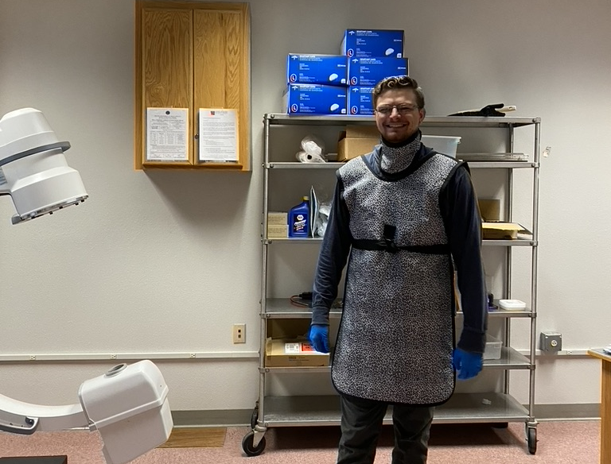
Figure 4: Hunter Gaines assisting with fluoroscope use

Testing Procedure 2: Schedule
This testing is contingent on the completion of a successfully curing clot with contrast, which the team has not yet achieved. The timeline for this clot will be completion in January, with subsequent testing taking 2-4 weeks depending on client feedback.

Testing Procedure 3: Benchtop Occlusion
The benchtop occlusion test will be used to determine how well the thrombi obstruct flow. This is relevant because it indicates how well the synthetic thrombi simulate stroke, and how they will interact with the stroke retrieval devices.

Testing Procedure 3: Objective
The objective of the benchtop occlusion test will be to determine how much flow is obstructed by the synthetic thrombi. This objective is to obtain a supplemental piece of flow information for clot deployment for the client. This testing procedure is a lower priority than the other two previously listed. This testing will involve the deployment of the synthetic thrombus into a flow model, with calibrated pressure transducers in a controlled, pulsatile flow. The changes in pressure for the vessel in which the clot is placed will be observed using LabVIEW data acquisition. This test will be repeated multiple times to see the different ways that flow could be occluded.

Testing Procedure 3: Resources Required
This test will require use of LabView, pressure transducers, and the benchtop flow meter. Since this setup is already in use at the Bioengineering Devices Laboratory, the testing will take place in the lab. This test will require team members use pressure transducers, a sphygmomanometer and LabVIEW. One to three people can help run this test, depending on the volatility of the benchtop model. Figure 5 shows this model.
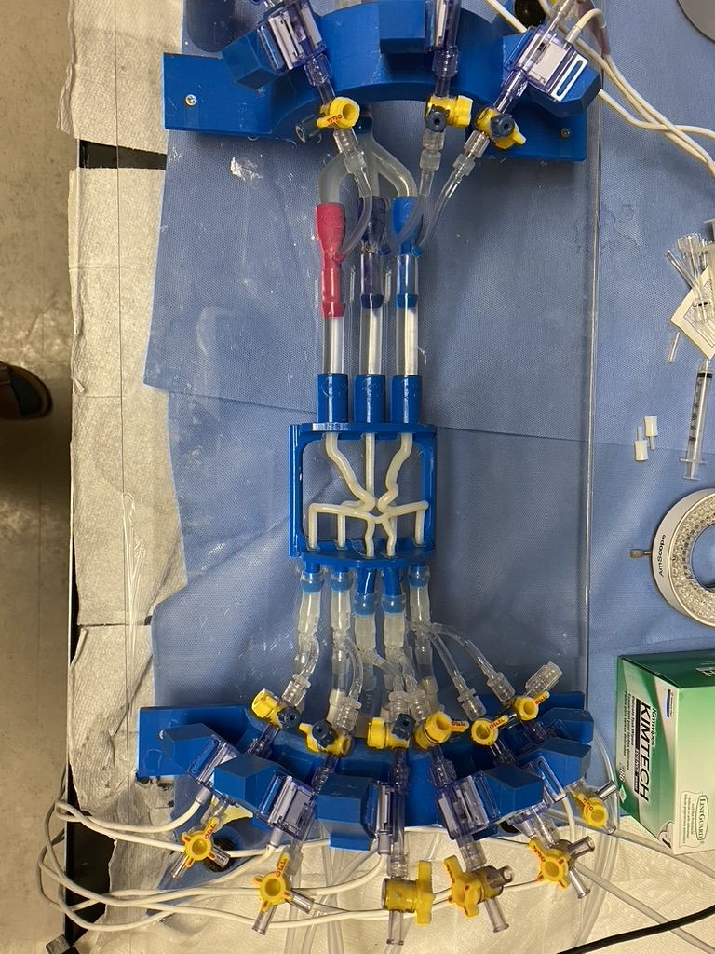
Figure 5: Benchtop flow model

Testing Procedure 3: Schedule
This testing will take 1-2 weeks depending on the predictability of the flow model. Occasionally, the flow model has issues with flow pressures due to a problem with the pump. This testing will likely take place in February.

Risk Analysis and Mitigation
The greatest critical failures for this capstone per the FMEA is the clot drying out, the clot absorbing moisture, air and light exposure, and customer complaints due to the dye not being dark or light enough. The dye is considered because there is no standard on “redness” needed for a clot and it appears to be a personal preference so it would be difficult to mitigate that risk. In the following section, the subsystems will be discussed as a whole and analyzed to see the risks at each stage of the manufacturing process and testing process. For this specific capstone, an analysis in this way is extremely valuable to see the risks the team faces at each stage instead of just the final product, therefore the entire table was placed in the main part of the report.
This section will discuss the possible project failure modes and the necessary mitigations to reduce failure potential. A failure modes effect analysis (FMEA) was used to determine the highest potential for risk, and the team brainstormed to determine solutions.

Critical Failures
Table 1 presents the highest risk 10 failures found through an FMEA. Most of the top 10 risks are in the storage subsystem. The highest risk is product application, where the clots can dry out prior to use.
Table 1: FMEA
Part # and Functions | Potential Failure Mode | Potential Effect(s) of Failure | Potential Causes and Mechanisms of Failure | RPN | Recommended Action
Manufacturing Modes of Failure Subsystem: Chemicals
Dye | Color too light or dark | Customer is unhappy with product | Customer complaints, unable to see clot deployed in model | 162 | Send small samples to customers so they can select the amount of dye they want in their clots.
Manufacturing Modes of Failure Subsystem: Curing
UVC Cure | Under cure | UVC is unable to penetrate storage used for mixture | Liquid clot | 100 | Automated system to dispense thin layers of mixture for even cure and use exposed molds for best effect
Product Modes of Failure Subsystem: Testing Properties
Clot | Drying out | Exposure to air changes mechanical properties | Results are inaccurate | 350 | Keep water around the sample while testing
Product Modes of Failure Subsystem: Application of Product
Clot | Water Absorption | Bloated sample expanding both laterally and axially | Exceeds the size of the system and becomes trapped, too much restriction of flow | 500 | Provide customers with information regarding how to effectively use the material
Clot | Drying Out | Shrinking sample becoming brittle and hard | Clot is unable to be deployed or used in the system | 800 | Provide customers with information regarding how to effectively use the material
Product Modes of Failure Subsystem: Storage
Syringe | Light exposure | UV rays degrade the material overtime | Mechanical properties are no longer consistent | 84 | Keep in poly bags
Test tube | Light exposure | UV rays degrade the material overtime | Mechanical properties are no longer consistent | 224 | Keep in poly bags
Test tube | Air exposure | Dries out sample | Mechanical properties are no longer consistent | 400 | Introduce an element of moisture that is not touching the material
Glass sample jar | Light exposure | UV rays degrade the material overtime | Mechanical properties are no longer consistent | 224 | Keep in poly bags
Glass sample jar | Air exposure | Dries out sample | Mechanical properties are no longer consistent | 500 | Introduce an element of moisture that is not touching the material

Potential Critical Failure 1: Chemical Failures
The chemical failures involved with this Capstone project have a wide range of implications. The largest struggle that the team will have to combat is the storage and the race against time regarding the chemical's degradation. Several of these products are highly reactive or hydrophilic making it highly likely that the chemicals degrade slightly with every use. These failures could cause batches to be inconsistent in their mechanical properties, appearance, and curing. This is very important to avoid since there are so many components that go into making a batch of synthetic thrombus, it would be difficult to figure out which chemical is causing the discrepancy. This will be prevented by limiting the number of people interacting with the chemicals, storing chemicals in their appropriate cabinets, and limiting the exposure to the outside elements by opening the lids for the shortest amount of time possible.
The other chemical failure that it is important to discuss does not impact the final product as much as it does the environment and the health of the chemists. As engineers, it is important to assess the environmental impact of our product alongside that of the potential mechanical failures. Several of these chemicals are toxic to humans as well as aquatic life. Several live animal experiments using the chemicals showed signs of cancer, mutations, damage to ovarian tissue and nerve damage from prolonged exposure. Since the team is interacting with these chemicals' multiple times a week, these impacts were taken into consideration. To prevent any discomfort or long-term damage to the lab technicians, it is important that all personal protective equipment is always worn when mixing a batch of synthetic thrombus and always performed under the fume hood to prevent inhalation of any chemical dust. The future preventative measures that should be taken is to prevent any food from entering the lab while this capstone is in progress. The risk of dust settling on tables or being tracked away from the hood is too great to ignore and many people are in the lab daily increasing their chance of ingesting the hazardous chemicals.

Potential Critical Failure 2: Curing Failures
The potential critical failures involved with the curing process are less impactful since it is easy to see if a clot cured correctly by checking the consistency of the clot or by inspecting its appearance. There are several steps in the curing process of a clot, introducing the slurry and making sure it distributes evenly throughout the mixture, degassing the mixture and using either an incubator or UVC box to cure the mixture. If the slurry does not mix properly the batch will become clumpy and unable to use, this is harder to prevent and is better to leave the mixing of the slurring to a well-seasoned lab technician. The degassing method currently used in the laboratory is a manual vacuum that must be released every 3-10 seconds to prevent the mixture from overflowing and can take as long as 4 hours to complete. Due to the manual labor involved, the team generally stops degassing after an hour. This could be improved by creating a manual system that cycles between on and off for several hours and would reduce the need for a person to be present during this time. It would also yield more accurate results of the final product. The final failure involved with the curing process is the method used, for now the team is only using incubation, and this was given a low impact value due to the team finding the correct cure time and having replicated several successful batches using the method. In future, the team will be exploring the curing method of UVC to see if the final product can be produced in a quicker amount of time. These methods will be difficult to perfect due to the limitation of UVC rays and have been given a high RPN value.

Potential Critical Failure 3: Material Testing Failures
- Testing failures are the most common failures experienced at this stage in the capstone project. The team is learning more about the mechanical properties of the synthetic thrombi and adjusting the material tests to avoid damaging the sample. However, if the test is run at forces too low, the data is unusable as it is incoherent. This failure is being mitigated using meticulous trial and error, with lots of documentation. The client is also helping to set up the material test since he is very knowledgeable about the mechanical properties involved. So far, the team has made good progress in test development, and we foresee less failures in the future. We will not stop honing the process until we are confident it will not result in project failure.
Another testing failure experienced is slippage during torsion tests which is due to the clot drying out and shrinking. It also can be caused by inaccurate placement of the sandpaper used to hold the small sample in place. The diameter of the clot that is being tested is 4mm which leaves a lot of room for error when trying to place the sandpaper on the rheometer. This could be prevented by creating a special tool that wraps around the rheometer attachment and places the sandpaper perfectly underneath it. This also could be prevented by using a larger sample size such as the puck. To achieve this, the team would have to send out molds to the manufacturers to see if they would be willing to cure their batches in the molds and send them to us.
- Some other ways, aside from method, that the material testing could fail would be the use of too much fluid, too little fluid, not securing the rheometer equipment, failing to calibrate the system, or failing to load the correct testing procedure. Also, on occasion, the TRIOS software crashes and deletes collected data. For these reasons, it is important that all team members are paying close attention while testing and setting up experiments. Further, it is important to save data as we move along, to ensure that nothing is lost.

Potential Critical Failure 4: Benchtop Occlusion Testing Failures
Bench testing how this final product will be used, the product will be deployed into artificial arteries to record the impacts of flow and the ability for certain medical devices to remove the clot. The materials used in the benchmark tests will simulate that of the human body so the frequency will not exceed 1 hertz, so the failure method discussed with the rheometer is not a problem for the bench test. The greatest challenge with the synthetic clot is being able to keep the clot in the perfect environment to prevent degradation via drying out of absorbing too much water. During testing on the rheometer, there have been signs leading to 1 hour of water exposure causing the mechanical properties to change and 10 minutes of exposure to body temperature also causing the properties to change. To prevent the end user from experiencing size or property changes, further tests will be performed and detailed instructions on the length of time these clots should be deployed in a bench test will be shipped with the clots.
- Major failures in this stage of the project lie more within the benchtop model than the actual synthetic thrombus. For example, the pump that controls the pulsatile flow for the model has been experiencing technical difficulties over the last six months, where the piston malfunctions or the O-ring air seal slips and bubbles bleed into the system. Currently, other lab members are working on fixing these issues, and this mitigation is the best we can hope for regarding these tests. If the pump is not fixed, we might try a different method, but after speaking with the client, it seems as though this test is a low priority for the time being. He is not overly concerned if this data is not collected.
- Other ways of collecting this data could be using a different pump or using a bucket timer method to measure outflow. Since the latter is very unprecise and crude, we would like to avoid using this system. It is our impression that the client would rather us collect no data than use an alternate method from the benchtop design, since that is where the synthetic thrombi will eventually be deployed in the lab.

Potential Critical Failure 5: Storage Failures
- The final critical failure is long term storage. These storage methods have all worked well for the course of a week or so, but these samples should ideally last longer. The biggest risk of storage failure is that the thrombus samples will dry out before we are able to test them. The team has been experimenting with different storage methods to mitigate this risk. So far, the most significant way of solving this issue is keeping the clots in their syringes until they are to be tested. It helps if the clots are stored in a non-light penetrable vessel, such as a cardboard box. Once the samples are cut, they can be stored in airtight containers, away from light exposure, with a small amount of moisture. They should not be suspended in moisture, to avoid degradation, but rather a few drops of distilled water can be added to the container to improve the humidity of the vessel and keep the samples moist.

Risks and Trade-offs Analysis
In this section, the comparisons of different failure methods and how these failures have led to the design currently being tested now. There will be a description of what the team initially wanted, what was changed and why it is a risk the team was willing to take. The critical failure methods will be explored and compared in depth for size, comparability, curing, testability, bench testing and storage. Overall, there are few risk trade-offs for this design. For the most part, mitigating risk in one area reduces risk in the other areas, because limiting variability is best in experimental design and execution. For instance, finding a good way to keep samples moist (mitigates storage failure) also reduces the variability in the material testing. Additionally, reducing risk of curing facility and chemical failure will improve the consistency of the material properties, because all thrombi will follow a finely tuned manufacturing and curing method. Thus, our design decision did not rely too heavily on potential failures, because the goal of our project is to improve the predictability of this design. The only obvious trade off at this stage of the project is that the material properties of a radiopaque clot might be different than those of a non-fluorescing clot. This is important because material properties and radiopacity are both highly prominent customer requirements, so we will need to do substantial material testing to mitigate the risks presented by this chemical change. Otherwise, there are not any obvious increases in risk. The investigation in this section will reflect the best analysis we could perform given these circumstances/

Risks and Trade-offs of Size Versus Comparability
The size of the sample in use is extremely important to the accuracy of the results received on the rheometer; the smaller the sample, the more precise the experimenter needs to be to get accurate results. Ideally, for testing the team would like to use a puck 8mm x 4mm to have the most accurate results, however this is a trade-off that the team has made to ensure that our samples are as accurate and comparable to that of the samples that were sent in from other companies. This risk will allow the team to have data that is easy to follow, easy to compare and ideally easy to replicate.

Risks and Trade-offs of Curing Versus Testability
The risks and trade-offs involved with the curing process are mostly time. The time it takes to cure a sample using the incubator is significant ranging from 72 hours to a week depending on the size of the syringe. Ideally, the team would prefer to use a method such as UVC curing or another method of delivering heat to cure more quickly and efficiently. These alternative methods are not possible now due to the nature of how the samples have been cured. The team is limited to curing in a syringe of 4mm diameter and UVC rays cannot penetrate the plastic or glass. For this reason, the team is sacrificing time to compensate for testability and accuracy of our tests. Once the material has been confirmed to match the mechanical properties at the 4mm size, the team can explore further options to increase the cure time.

Risks and Trade-offs of Bench Testing Versus Storage
The trade-offs involved with bench testing versus storage are quite significant due to the materials ability to wick up and excrete moisture at a fast rate. This makes storage a very difficult challenge and forces the team into using a syringe so the end user can extrude only what they need and keep the rest protected from air exposure. The team has experimented with storing the synthetic thrombus in several different containers, all resulting in the sample drying out before it could be tested again. The mechanical properties change dramatically when exposed to water or the lack of water which makes storage a very serious problem to ensure that the devices being tested are experiencing the same mechanical properties that have been recorded. For this reason, the team will be taking time to explore mechanisms of storage to optimize the protection of the material despite it being a sidetrack from the main goal of the capstone.

Design Selection—First Semester
The design selection was done using a Pugh chart (Appendix B) and the House of Quality already presented. The engineering requirements and customer requirements were compared and then weighted to be placed into the matrices. These two charts were then used to rank the design criteria to determine which design would be most suitable for this project.

Design Description
The final chemical manufacturing process is largely the same as that outlined in the functional decomposition (Figure 2). This process involves mixing, degassing, and heat curing to obtain a fully gelled thrombus that retains its shape, does not particulate, and does not degrade significantly in fluid. Figure 6 shows part of the manufacturing process. Using the BDL’s fume hood.
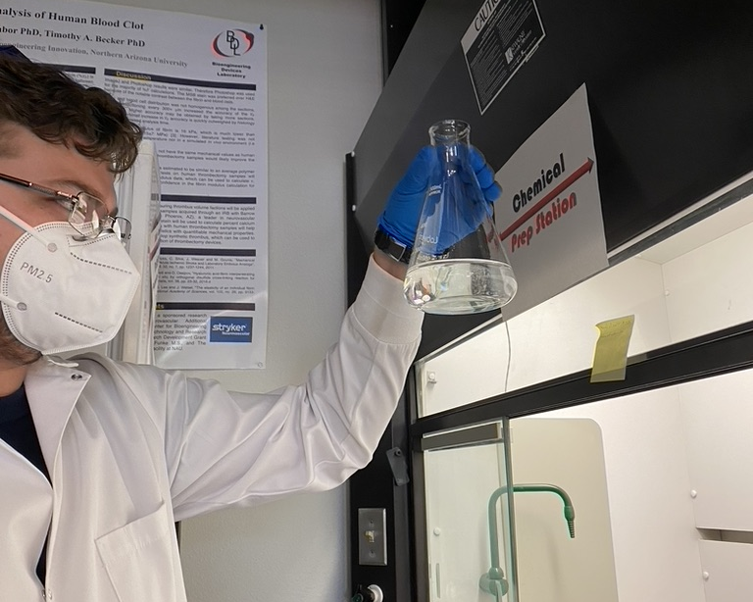
Figure 6: Manufacturing synthetic thrombi
The final design decision is a 1 mL syringe. While the puck design had the highest score on the Pugh chart, the pucks are not usable in benchtop testing models. The 1 mL syringe was useful for storage and benchtop testing but must be modified (cut) for material testing
Figure 7 shows the clots in syringes. These clots are heat cured and can be deployed in the BDL benchtop vessel model.
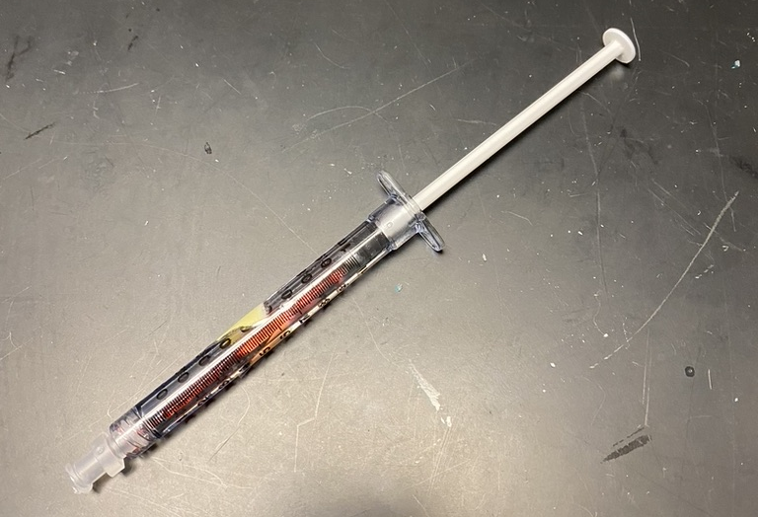
Figure 7: Synthetic thrombus cured in a syringe.
After being deployed from the syringe (Figure 8, right), the synthetic clots retain their cylindrical shape. After analysis using calipers, these clots measure 4 mm in diameter, and vary in length. These samples are cut into 4mm length cylinders for material testing. They can be cut smaller or larger for benchtop use. This design has the most successful curing and storing properties thus far in the project investigation. Clot samples are stored in airtight jars, shown in Figure 8 (left). These samples are stored with a little bit of moisture, and in a light-safe (cardboard or solid plastic) bin to avoid degradation.
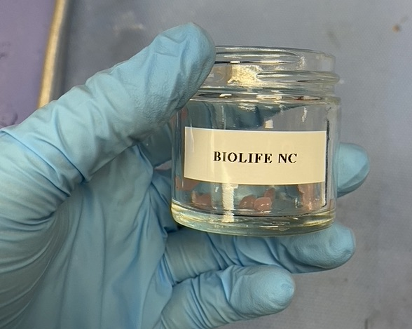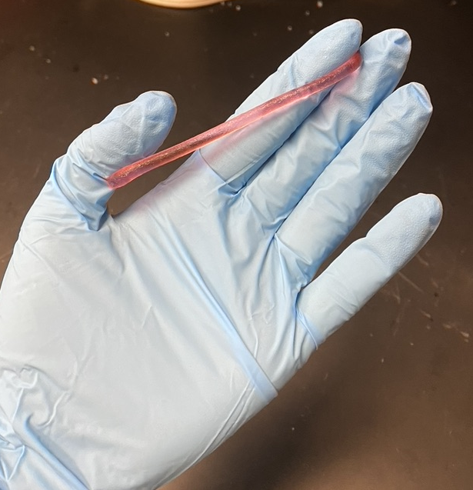
Figure 8: Left—clot samples and storage, right—clot after being deployed from syringe.

Implementation Plan
Our design will be implemented by physical prototyping and iterative feedback. The only way to achieve results for these samples is to create many different types of samples, troubleshoot the manufacturing process, and fully characterize each material. To ensure that all manufacturing and testing will be completed on time, the team is utilizing a calendar to keep track of important dates. The client is consulted at least once per week, to ensure that all the team activities are on track.
The timeline for spring semester is detailed in Table 2.
Table 2: Spring Semester Schedule
Month | Task | Est. Time | Resources Required
January | Material testing, radiopacity testing, clot manufacturing | Material: 8-12 wks.  Radiopacity: 1-2 wks.  Clot mfg.: 8-12 wks. | Bioengineering Devices Laboratory Rheometer, C-arm fluoroscope, chemicals, PPE, syringes
February | Material testing, benchtop occlusion testing, clot manufacturing | Material: 4-8 wks.  Benchtop: 2 wks.  Clot mfg.: 4-8 wks. | Bioengineering Devices Laboratory Rheometer, benchtop flow model, LabVIEW, pressure transducers, chemicals, PPE, syringes
March | Material testing and statistical analysis, clot manufacturing | Material: 0-4 wks.  Statistics: 1-2 wks.  Clot mfg.: 0-4 wks. | Bioengineering Devices Laboratory Rheometer, chemicals, PPE, syringes
April | Present at NAU’s Undergraduate Symposium | 1-2 wks. | Printing services, BDL capstone presentation templates, Microsoft Office
May | Present findings to capstone class and client | 2 wks. | Microsoft Office

Currently, we are collaborating with two companies to materially characterize their synthetic thrombi. We are not purchasing these clots, rather using samples obtained through contacts at each company. Thus, we do not foresee needing to order more, at least not using the budget. The final CAD for our design is shown in Figure 9. The final bill of materials is shown in Table 3.
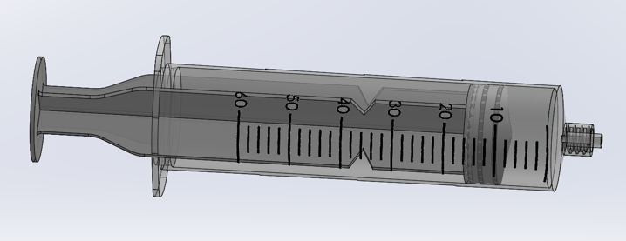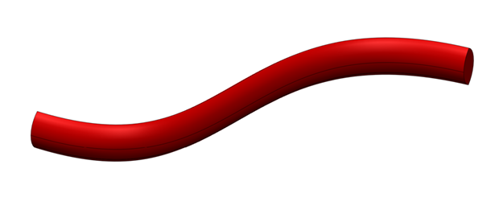
Figure 9: Final CAD of a deployed clot and syringe
Table 3: Final Bill of Materials
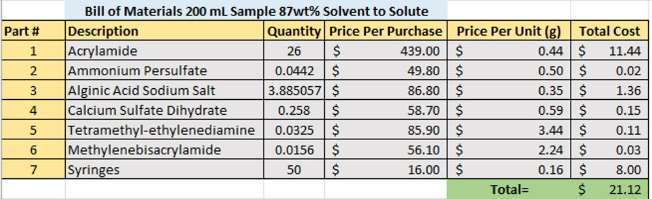

CONCLUSIONS
The team has had many successes throughout the semester while working on this project. The main objective was to solidify a manufacturing process for the clots and be able to replicate it without failure. As seen in the report, there are many potential failure modes when working with the reactants required to create synthetic thrombi. After much trial and error, the team was able to reduce the number of failures encountered throughout the manufacturing process and learned how to properly handle the chemical solution for the best results. Considering the success of the manufacturing process that has been put in place for the project, the team began focusing on the best methods for storage and clot shape(design) that would benefit the project the most.
The team used a series of selective process methods to determine the best approach to the goals of the project after the manufacturing portion was handled. These goals include testing material properties of the thrombi and achieving three different types of clots: soft, medium, and hard. The team is working towards a standard of procedure for creating the different types of clots and is now beginning to test material properties. The team is slightly ahead of schedule for the material testing and will be focused more on testing products in the second semester of the project. Companies within the industry have provided the team with clots for comparing and contrasting. The team will use analyzation of the competing companies to further improve the design and standards of procedure being utilized by the clot capstone team.
Moving into the second semester, the team will work toward finalizing the design of the three different types of clots and have material property data that can describe each type of clot. The three different testing methods, previously mentioned, will be used to quantify the theory behind synthetic thrombi and provide the medical industry with an innovative solution for testing blood clots and blood clot technology.

REFERENCES
[1] “Stroke Facts & Statistics - Stroke Awareness Foundation.” https://www.strokeinfo.org/stroke-facts-statistics/ (accessed Oct. 20, 2022).
[2] J. K. Nicholls, J. Ince, J. S. Minhas, and E. M. L. Chung, “Emerging Detection Techniques for Large Vessel Occlusion Stroke: A Scoping Review,” Front. Neurol., vol. 12, p. 2477, Jan. 2022, doi: 10.3389/FNEUR.2021.780324/BIBTEX.
[3] W. Merritt et al., “Quantifying the mechanical and histological properties of thrombus analog made from human blood for the creation of synthetic thrombus for thrombectomy device testing,” J. Neurointerv. Surg., vol. 10, no. 12, pp. 1168–1173, Dec. 2018, doi: 10.1136/NEURINTSURG-2017-013675.
[4] N. G. Norris, W. C. Merritt, and T. A. Becker, “Application of nondestructive mechanical characterization testing for creating in vitro vessel models with material properties similar to human neurovasculature,” J. Biomed. Mater. Res. A, vol. 110, no. 3, pp. 612–622, Mar. 2022, doi: 10.1002/JBM.A.37314.
[5] N. Wortmann et al., “Development of synthetic thrombus models to simulate stroke treatment in a physical neurointerventional training model,” https://doi.org/10.1080/26895293.2022.2046181, vol. 15, no. 1, pp. 283–301, 2022, doi: 10.1080/26895293.2022.2046181.
[6] S. Sarkar, “Artificial blood,” Indian J. Crit. Care Med., vol. 12, no. 3, p. 140, Jul. 2008, doi: 10.4103/0972-5229.43685.
[7] I. Kan et al., “Technical Note: A Novel Method of Thrombus Preparation for Use in a Swine Model for Evaluation of Thrombectomy Devices,” AJNR Am. J. Neuroradiol., vol. 31, no. 9, p. 1741, Oct. 2010, doi: 10.3174/AJNR.A1991.
[8] D. N. Sarode and S. Roy, “In Vitro models for thrombogenicity testing ofblood-recirculating medical devices,” Expert Rev. Med. Devices, vol. 16, no. 7, p. 603, Jul. 2019, doi: 10.1080/17434440.2019.1627199.
[9] N. Krasokha et al., “Mechanical properties of blood clots – a new test method,” Materwiss. Werksttech., vol. 41, no. 12, pp. 1019–1024, Dec. 2010, doi: 10.1002/MAWE.201000703.
[10] N. Boodt et al., “Mechanical Characterization of Thrombi Retrieved with Endovascular Thrombectomy in Patients with Acute Ischemic Stroke,” Stroke, vol. 52, pp. 2510–2517, 2021, doi: 10.1161/STROKEAHA.120.033527.
[11] J. H. Ashton, J. P. Vande Geest, B. R. Simon, and D. G. Haskett, “Compressive mechanical properties of the intraluminal thrombus in abdominal aortic aneurysms and fibrin-based thrombus mimics,” J. Biomech., vol. 42, no. 3, pp. 197–201, Feb. 2009, doi: 10.1016/J.JBIOMECH.2008.10.024.
[12] A. K. Bajpai and M. Shrivastava, “DYNAMIC SWELLING BEHAVIOR OF POLYACRYLAMIDE BASED THREE COMPONENT HYDROGELS,” http://dx.doi.org/10.1081/MA-100101141, vol. 37 A, no. 9, pp. 1069–1088, 2007, doi: 10.1081/MA-100101141.
[13] S. Pourshahrestani, E. Zeimaran, N. A. Kadri, N. Mutlu, and A. R. Boccaccini, “Polymeric Hydrogel Systems as Emerging Biomaterial Platforms to Enable Hemostasis and Wound Healing,” Adv. Healthc. Mater., vol. 9, no. 20, p. 2000905, Oct. 2020, doi: 10.1002/ADHM.202000905.
[14] G. M. Gunning, K. McArdle, M. Mirza, S. Duffy, M. Gilvarry, and P. A. Brouwer, “Clot friction variation with fibrin content; implications for resistance to thrombectomy,” J. Neurointerv. Surg., vol. 10, no. 1, pp. 34–38, Jan. 2018, doi: 10.1136/NEURINTSURG-2016-012721.
[15] “Properties of Materials,” Mater. Handb., pp. 1–57, 2008, doi: 10.1007/978-1-84628-669-8_1.
[16] H. Guerreiro et al., “Novel synthetic clot analogs for in-vitro stroke modelling,” PLoS One, vol. 17, no. 9, p. e0274211, Sep. 2022, doi: 10.1371/JOURNAL.PONE.0274211.
[17] D. J. Carr, T. Stevenson, and P. F. Mahoney, “The use of gelatine in wound ballistics research,” Int. J. Legal Med., vol. 132, no. 6, pp. 1659–1664, Nov. 2018, doi: 10.1007/S00414-018-1831-7/FIGURES/4.
[18] “Cerebral vein and cerebral venous sinus thrombosis.”
[19] “Industrial Autoclaves | Laboratory Sterilizers | Priorclave.” https://www.priorclave.com/en-us/ (accessed Oct. 23, 2022).
[20] “The Challenge of Working in a Cleanroom.” https://cleanroom-industries.com/index.php/resources/the-challenge-of-working-in-a-cleanroom/408 (accessed Oct. 23, 2022).
[21] “Percent by Weight Calculation | ChemTalk.” https://chemistrytalk.org/percent-by-weight-calculation/ (accessed Oct. 23, 2022).
[22] “Thrombectomy Device - an overview | ScienceDirect Topics.” https://www.sciencedirect.com/topics/nursing-and-health-professions/thrombectomy-device (accessed Oct. 23, 2022).

APPENDICES

Appendix A: Complete FMEA
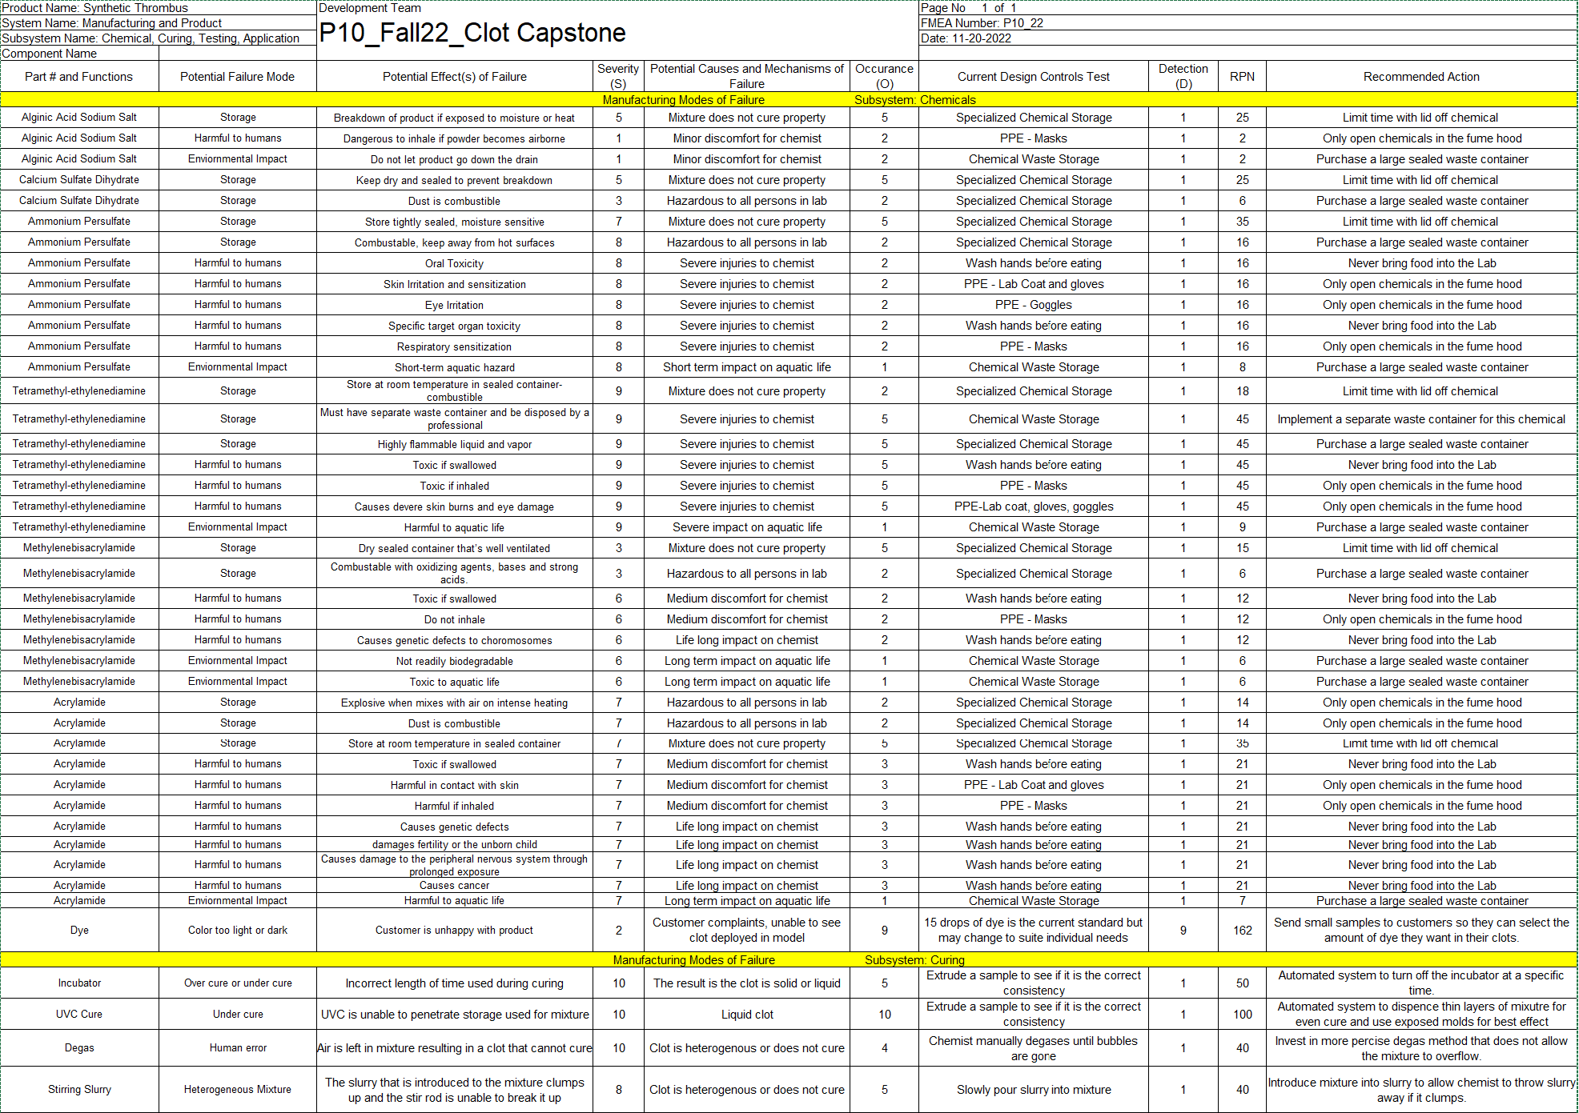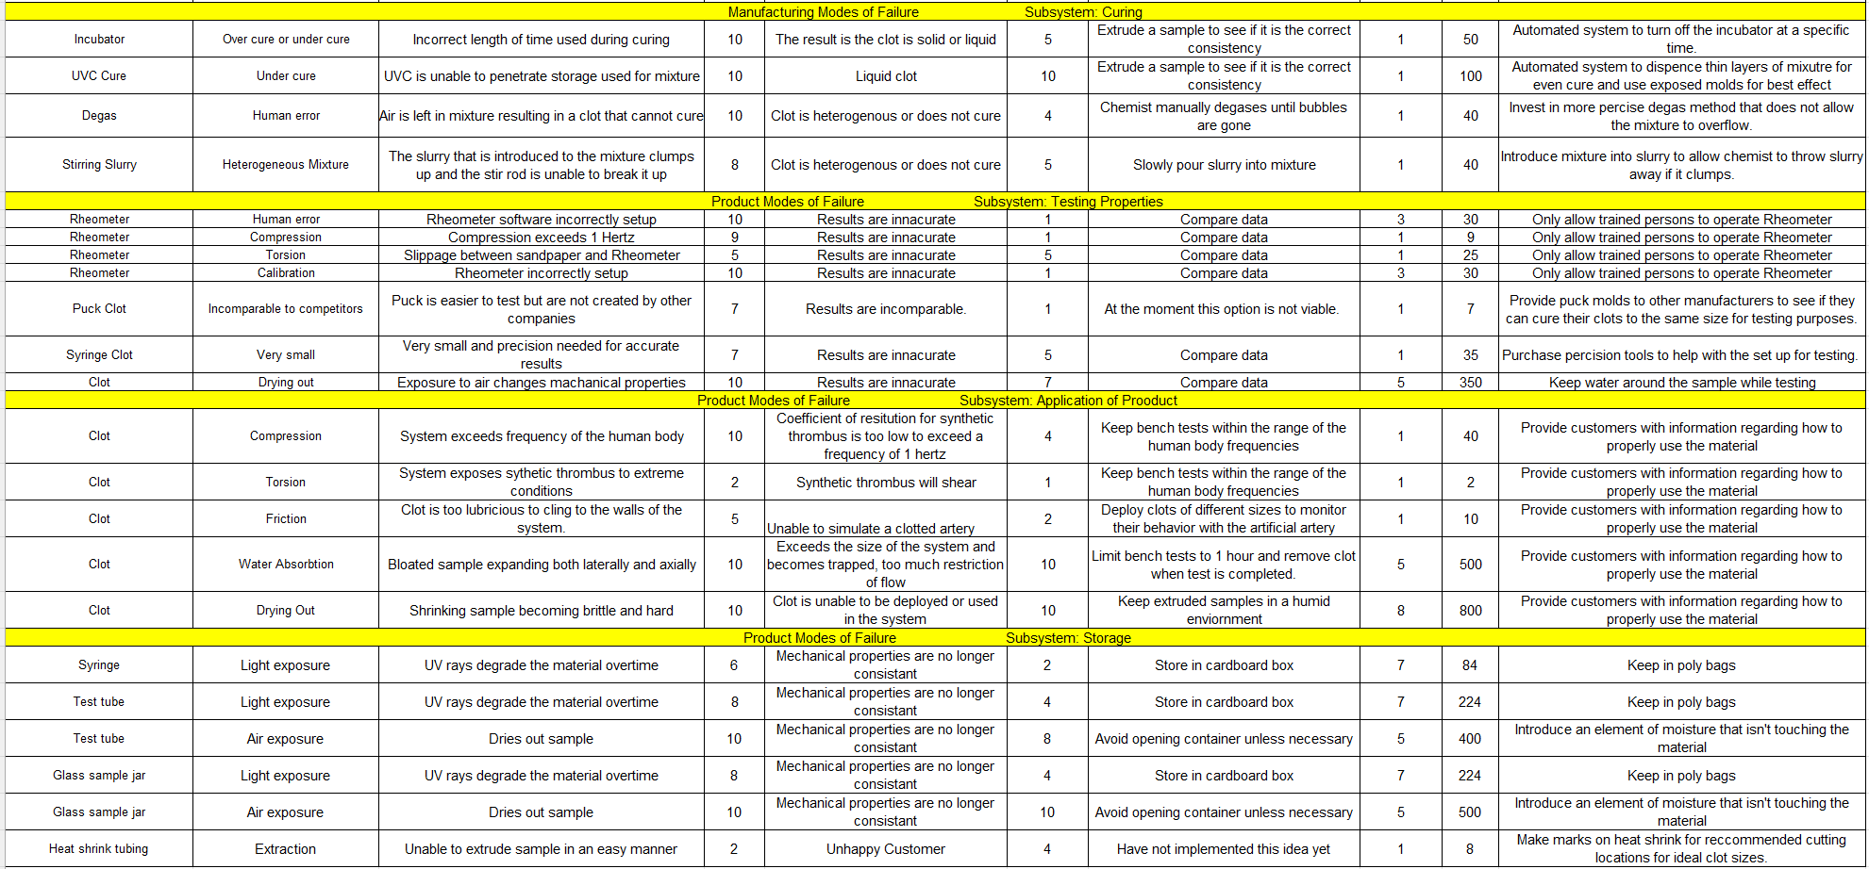

Appendix B: Design Selection Materials
Pugh Chart
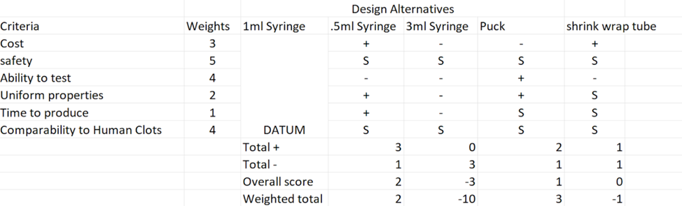

Appendix C: Final CAD and BOM

Clots after removal from syringe, simulated using CAD.

Final Bill of Materials

